### [**Nativity Christmas Ornament**](https://papercraftetc.blogspot.com/2018/12/nativity-christmas-ornament.html)



I love the way that the star radiates on top of this nativity ornament. I used gold metallic card stock to make this ornament. It's pretty simple to make. Glue the corresponding image together. Glue three together, add the hangar circle on top and then glue the other three images together to complete the scene. Make the base and slide the scene into the base.

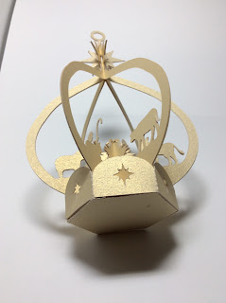

Bottom View

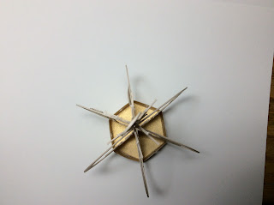

Top View